RaceFinder results analysis

Prepared for

Dr. Shmuel Ur

Prepared by

Dan Goldwaser 033395674
Idan Elfassy 034990820

Software testing course
Department of computer science
University of Haifa
Table of Contents

1. Document Overview 3
2. Application under test overview 4
2.1. General overview 4
2.2. Application flow 4
2.3. Bugs and interleaving description 4
3. Tests and tests results 6
3.1. Test overview 6
3.2. Test description 6
3.3. Tests and Results 8
4. Results analysis 16
4.1. General Statistics 16
4.2. Bug distribution according to variables 17
4.3. distribution according to noise applied 18
5. Summary 19

- Document Overview

This document specifies and analyzes the tests and test results made to shop application using the RaceFinder tool.
This document is submitted as software testing course final assignment.

The document is structured as follows:

- Section 1 - Document overview.
- Section 2 Application under test overview
- Section 3 - Tests and results
- Section 4 - Results analysis
- Section 5 - Summary

- Application under test overview

  - General overview

Shop keeping application, simulates the operation of shop business day:
Supplier supplies goods to the shop’s storage and costumers buy goods from the shop.
The application has four classes:
- Shop – the main thread, handles the activation of other threads in the application.
- Supplier – implemented as a thread, puts goods in the shop – increases the value of shop’s storage variable.
- Costumer – implemented as a thread , removes goods from the shop – decreases the value of shop’s storage variable.
- Signal – handles the output file.

  - Application flow

The application begins by invoking the supplier thread a 10 ms sleep time slice is presumably enough for the supplier.
The supplier uses shop’s putItem() synchronized method.
Shop class invokes customers – according to concurrency level : low -2 costumers , average -3 costumers and high – 6 costumers.
The costumers use Shop’s getItem() synchronized method.
Once all costumers acquired all items the application prints the output file and terminates.

  - Bugs and interleaving description

Two bugs were implemented:
- Denial (sleep) – the supplier time slice expires before all items were supplied.
This may result in costumer trying to buy when the shop is empty – the costumer will then “give up” and would buy one less item or in the next bug

- Lock unlock lock – if the sleep bug occurs and the shop is empty the costumer should not be able to buy. However a two stage lock is implemented and may result in two costumers (or more ) trying to purchase the last item. If this occurs the costumer would “leave the store” and that costumer thread would terminate.
Possible interleaving for this thread would be:

1 if(!my_shop.isEmpty()){
try{
2 my_shop.getItem();
purchasedItems++;
System.out.println("Got it");
i--;
}

Costumer 1 | Costumer 2 | Items left
1 |  | 1
 | 1 | 1
2 |  | 0
 | 2 | Bug

Table 1: bug interleaving

- Tests and tests results

  - Test overview

This paragraph shall detail all tests and test results done on the application using RaceFinder.
The tests cover the application raced variables as depicted in table 2, subsets of 2 variables and white noise. All noise types were tested on these variables- yield, barrier, take lock before/after and apply noise before/after event.
Percentage value is covered in the following manner:: the tests range from: low 30%, average 60% and high 90% (100% may cause an infinite loop)

  - Test description

The test description is in 3 tables:
- Table 2 – application variables and a key to be used in the test description table
- Table 3- bug patterns and a key to be used in the test description table
- Table 4 – test description and results table

Application Variables
Other Variables (unaffected) | Shared Variables (race condition) | Serial number
costumer.S | supplier.supply_address | 1
shop.costumers_amount | costumer.my_shop | 2
costumer.shopping_list | shop.items | 3
costumer.lock | Signal.i | 4
shop.S | shop.storage | 5
supplier.itemsToBeSupplied
costumer.out
costumer.id
costumer.purchasedItems

Table 2 – application variables

Test result
Bug pattern name | Bug pattern key
None | n
denial ( initialization sleep) | s
weak reality (lock unlock lock) | l

Table 3- bug patterns and a key

  - Tests and Results
Bug pattern | Noise before\ after | Take lock before\after | barrier | yield | White noise | subset | single | Con.  level | Num. of tests | Test group id
s2/l 18 | Before | before |  | 30/30/ |  |  | 1 | lot | 20 | 1
s7/l 13 | after | after |  | 30/30/ |  |  | 1 | lot | 20
n19/l 1 | after | before |  | 30/30/ |  |  | 1 | lot | 20
s8/l 12 | Before | after |  | 30/30/ |  |  | 1 | lot | 20
s9/ l 11 | Before | before |  | 60/60/ |  |  | 1 | lot | 20
s14 /l 6 | after | after |  | 60/60/ |  |  | 1 | lot | 20
n19/ s 1 | after | before |  | 60/60/ |  |  | 1 | lot | 20
s14/l 6 | Before | after |  | 60/60/ |  |  | 1 | lot | 20
s 17/l 3 | Before | before |  | 90/90/ |  |  | 1 | lot | 20
n 20 | after | after |  | 90/90/ |  |  | 1 | lot | 20
n 20 | after | before |  | 90/90/ |  |  | 1 | lot | 20
s 12/ l 8 | Before | after |  | 90/90/ |  |  | 1 | lot | 20
s12/l 8 | Before | before | 30/5/10 |  |  |  | 1 | lot | 20
n 20 | after | after | 30/5/10 |  |  |  | 1 | lot | 20
n 20 | after | before | 30/5/10 |  |  |  | 1 | lot | 20
s10/l 10 | Before | after | 30/5/10 |  |  |  | 1 | lot | 20
s16/ l 4 | Before | before | 0/5/106 |  |  |  | 1 | lot | 20
n 20 | after | after | 0/5/106 |  |  |  | 1 | lot | 20
n20 | after | before | 0/5/106 |  |  |  | 1 | lot | 20
s 14/l 6 | Before | after | 0/5/106 |  |  |  | 1 | lot | 20
s16 /l 8 | Before | before | 90/5/10 |  |  |  | 1 | lot | 20
n 20 | after | after | 90/5/10 |  |  |  | 1 | lot | 20
n 20 | after | before | 90/5/10 |  |  |  | 1 | lot | 20
s10/ l10 | Before | after | 90/5/10 |  |  |  | 1 | lot | 20
n8/s4/l 8 | Before |  |  | 30/30/ |  |  | 1 | lot | 20
n 18/s 2 | after |  |  | 30/30/ |  |  | 1 | lot | 20
n16/s2/l2 | Before |  |  | 60/60/ |  |  | 1 | lot | 20
n16/ l 4 | after |  |  | 60/60/ |  |  | 1 | lot | 20
n14/l 6 | after |  |  | 90/90/ |  |  | 1 | lot | 20
n2/s10/ l 8 | Before |  |  | 90/90/ |  |  | 1 | lot | 20
n 20 | after |  | 30/5/10 |  |  |  | 1 | lot | 20
s6 /l14 | Before |  | 30/5/10 |  |  |  | 1 | lot | 20
n 20 | after |  | 0/5/106 |  |  |  | 1 | lot | 20
s8/ l 12 | Before |  | 0/5/106 |  |  |  | 1 | lot | 20
s12/ l 8 | Before |  | 90/5/10 |  |  |  | 1 | lot | 20
n 20 | after |  | 90/5/10 |  |  |  | 1 | lot | 20
s 20 | After/ before | After/ before | 90/5/10 | 90/90/ |  |  | 1 | lot | 20
Bug pattern | Noise before\ after | Take lock before\after | barrier | yield | White noise | subset | single | Con.  level | Num. of tests | Test group id
s2/l 18 | Before | before |  | 30/30/ |  |  | 2 | lot | 20 | 1
s7/l 13 | after | after |  | 30/30/ |  |  | 2 | lot | 20
n19/l 1 | after | before |  | 30/30/ |  |  | 2 | lot | 20
n19/l 1 | Before | after |  | 30/30/ |  |  | 2 | lot | 20
s14/l 6 | Before | before |  | 60/60/ |  |  | 2 | lot | 20
s14/l 6 | after | after |  | 60/60/ |  |  | 2 | lot | 20
s17/l 3 | after | before |  | 60/60/ |  |  | 2 | lot | 20
s2/l 18 | Before | after |  | 60/60/ |  |  | 2 | lot | 20
s7/l 13 | Before | before |  | 90/90/ |  |  | 2 | lot | 20
s14/l 6 | after | after |  | 90/90/ |  |  | 2 | lot | 20
s14/l 6 | after | before |  | 90/90/ |  |  | 2 | lot | 20
s17/l 3 | Before | after |  | 90/90/ |  |  | 2 | lot | 20
s2/l 18 | Before | before | 30/5/10 |  |  |  | 2 | lot | 20
s7/l 13 | after | after | 30/5/10 |  |  |  | 2 | lot | 20
n19/l 1 | after | before | 30/5/10 |  |  |  | 2 | lot | 20
n19/l 1 | Before | after | 30/5/10 |  |  |  | 2 | lot | 20
s17/l 3 | Before | before | 0/5/106 |  |  |  | 2 | lot | 20
s2/l 18 | after | after | 0/5/106 |  |  |  | 2 | lot | 20
s7/l 13 | after | before | 0/5/106 |  |  |  | 2 | lot | 20
s14/l 6 | Before | after | 0/5/106 |  |  |  | 2 | lot | 20
s17/l 3 | Before | before | 90/5/10 |  |  |  | 2 | lot | 20
s2/l 18 | after | after | 90/5/10 |  |  |  | 2 | lot | 20
s7/l 13 | after | before | 90/5/10 |  |  |  | 2 | lot | 20
s14/l 6 | Before | after | 90/5/10 |  |  |  | 2 | lot | 20
s17/l 3 | After/ before | After/ before | 90/5/10 | 90/90/ |  |  | 2 | lot | 20
s2/l 18 | Before |  |  | 30/30/ |  |  | 2 | lot | 20
s7/l 13 | after |  |  | 30/30/ |  |  | 2 | lot | 20
s14/l 6 | Before |  |  | 60/60/ |  |  | 2 | lot | 20
s17/l 3 | after |  |  | 60/60/ |  |  | 2 | lot | 20
s2/l 18 | after |  |  | 90/90/ |  |  | 2 | lot | 20
s7/l 13 | Before |  |  | 90/90/ |  |  | 2 | lot | 20
s14/l 6 | after |  | 30/5/10 |  |  |  | 2 | lot | 20
s17/l 3 | Before |  | 30/5/10 |  |  |  | 2 | lot | 20
s2/l 18 | after |  | 0/5/106 |  |  |  | 2 | lot | 20
s7/l 13 | Before |  | 0/5/106 |  |  |  | 2 | lot | 20
s14/l 6 | Before |  | 90/5/10 |  |  |  | 2 | lot | 20
s10n10 | after |  | 90/5/10 |  |  |  | 2 | lot | 20
l20 | After/ before | After/ before | 90/5/10 | 90/90/ |  |  | 2 | lot | 20
Bug pattern | Noise before\ after | Take lock before\after | barrier | yield | White noise | subset | single | Con.  level | Num. of tests | Test group id
L20 | Before | before |  | 30/30/ |  |  | 3 | lot | 20 | 1
L20 | after | after |  | 30/30/ |  |  | 3 | lot | 20
L20 | after | before |  | 30/30/ |  |  | 3 | lot | 20
L20 | Before | after |  | 30/30/ |  |  | 3 | lot | 20
L20 | Before | before |  | 60/60/ |  |  | 3 | lot | 20
L20 | after | after |  | 60/60/ |  |  | 3 | lot | 20
L20 | after | before |  | 60/60/ |  |  | 3 | lot | 20
L20 | Before | after |  | 60/60/ |  |  | 3 | lot | 20
L20 | Before | before |  | 90/90/ |  |  | 3 | lot | 20
L20 | after | after |  | 90/90/ |  |  | 3 | lot | 20
L20 | after | before |  | 90/90/ |  |  | 3 | lot | 20
L20 | Before | after |  | 90/90/ |  |  | 3 | lot | 20
L20 | Before | before | 30/5/10 |  |  |  | 3 | lot | 20
L20 | after | after | 30/5/10 |  |  |  | 3 | lot | 20
L20 | after | before | 30/5/10 |  |  |  | 3 | lot | 20
L20 | Before | after | 30/5/10 |  |  |  | 3 | lot | 20
L20 | Before | before | 0/5/106 |  |  |  | 3 | lot | 20
L20 | after | after | 0/5/106 |  |  |  | 3 | lot | 20
L20 | after | before | 0/5/106 |  |  |  | 3 | lot | 20
L20 | Before | after | 0/5/106 |  |  |  | 3 | lot | 20
L20 | Before | before | 90/5/10 |  |  |  | 3 | lot | 20
L20 | after | after | 90/5/10 |  |  |  | 3 | lot | 20
L20 | after | before | 90/5/10 |  |  |  | 3 | lot | 20
L20 | Before | after | 90/5/10 |  |  |  | 3 | lot | 20
L20 | After/ before | After/ before | 90/5/10 | 90/90/ |  |  | 3 | lot | 20
L4 | Before |  |  | 30/30/ |  |  | 3 | lot | 20
L18 | after |  |  | 30/30/ |  |  | 3 | lot | 20
S1 l 17 | Before |  |  | 60/60/ |  |  | 3 | lot | 20
L20 | after |  |  | 60/60/ |  |  | 3 | lot | 20
L 20 | after |  |  | 90/90/ |  |  | 3 | lot | 20
L20 | Before |  |  | 90/90/ |  |  | 3 | lot | 20
L20 | after |  | 30/5/10 |  |  |  | 3 | lot | 20
L20 | Before |  | 30/5/10 |  |  |  | 3 | lot | 20
L20 | after |  | 0/5/106 |  |  |  | 3 | lot | 20
L20 | Before |  | 0/5/106 |  |  |  | 3 | lot | 20
L20 | Before |  | 90/5/10 |  |  |  | 3 | lot | 20
L20 | after |  | 90/5/10 |  |  |  | 3 | lot | 20
L20 | After/ before | After/ before | 90/5/10 | 90/90/ |  |  | 3 | lot | 20
Bug pattern | Noise before\ after | Take lock before\after | barrier | yield | White noise | subset | single | Con.  level | Num. of tests | Test group id
L1 | Before | before |  | 30/30/ |  |  | 4 | lot | 20 | 1
L1 | after | after |  | 30/30/ |  |  | 4 | lot | 20
n | after | before |  | 30/30/ |  |  | 4 | lot | 20
n | Before | after |  | 30/30/ |  |  | 4 | lot | 20
n | Before | before |  | 60/60/ |  |  | 4 | lot | 20
n | after | after |  | 60/60/ |  |  | 4 | lot | 20
L1 | after | before |  | 60/60/ |  |  | 4 | lot | 20
L1 | Before | after |  | 60/60/ |  |  | 4 | lot | 20
L1 | Before | before |  | 90/90/ |  |  | 4 | lot | 20
L1 | after | after |  | 90/90/ |  |  | 4 | lot | 20
L20 | after | before |  | 90/90/ |  |  | 4 | lot | 20
L1 | Before | after |  | 90/90/ |  |  | 4 | lot | 20
n | Before | before | 30/5/10 |  |  |  | 4 | lot | 20
n | after | after | 30/5/10 |  |  |  | 4 | lot | 20
n | after | before | 30/5/10 |  |  |  | 4 | lot | 20
n | Before | after | 30/5/10 |  |  |  | 4 | lot | 20
n | Before | before | 0/5/106 |  |  |  | 4 | lot | 20
n | after | after | 0/5/106 |  |  |  | 4 | lot | 20
n | after | before | 0/5/106 |  |  |  | 4 | lot | 20
L1 | Before | after | 0/5/106 |  |  |  | 4 | lot | 20
n | Before | before | 90/5/10 |  |  |  | 4 | lot | 20
L2 | after | after | 90/5/10 |  |  |  | 4 | lot | 20
n | after | before | 90/5/10 |  |  |  | 4 | lot | 20
L1 | Before | after | 90/5/10 |  |  |  | 4 | lot | 20
L1 | Before |  |  | 30/30/ |  |  | 4 | lot | 20
n | after |  |  | 30/30/ |  |  | 4 | lot | 20
n | Before |  |  | 60/60/ |  |  | 4 | lot | 20
L1 | after |  |  | 60/60/ |  |  | 4 | lot | 20
N | after |  |  | 90/90/ |  |  | 4 | lot | 20
L1 | Before |  |  | 90/90/ |  |  | 4 | lot | 20
n | after |  | 30/5/10 |  |  |  | 4 | lot | 20
n | Before |  | 30/5/10 |  |  |  | 4 | lot | 20
n | after |  | 0/5/106 |  |  |  | 4 | lot | 20
n | Before |  | 0/5/106 |  |  |  | 4 | lot | 20
n | Before |  | 90/5/10 |  |  |  | 4 | lot | 20
L1 | after |  | 90/5/10 |  |  |  | 4 | lot | 20
L20 | After/ before | After/ before | 90/5/10 | 90/90/ |  |  | 4 | lot | 20
Bug pattern | Noise before\ after | Take lock before\after | barrier | yield | White noise | subset | single | Con.  level | Num. of tests | Test group id
L20 | Before | before |  | 30/30/ |  |  | 5 | lot | 20 | 1
n | after | after |  | 30/30/ |  |  | 5 | lot | 20
n | after | before |  | 30/30/ |  |  | 5 | lot | 20
L20 | Before | after |  | 30/30/ |  |  | 5 | lot | 20
L20 | Before | before |  | 60/60/ |  |  | 5 | lot | 20
n | after | after |  | 60/60/ |  |  | 5 | lot | 20
n | after | before |  | 60/60/ |  |  | 5 | lot | 20
L20 | Before | after |  | 60/60/ |  |  | 5 | lot | 20
L20 | Before | before |  | 90/90/ |  |  | 5 | lot | 20
n | after | after |  | 90/90/ |  |  | 5 | lot | 20
n | after | before |  | 90/90/ |  |  | 5 | lot | 20
L20 | Before | after |  | 90/90/ |  |  | 5 | lot | 20
L20 | Before | before | 30/5/10 |  |  |  | 5 | lot | 20
n | after | after | 30/5/10 |  |  |  | 5 | lot | 20
n | after | before | 30/5/10 |  |  |  | 5 | lot | 20
L20 | Before | after | 30/5/10 |  |  |  | 5 | lot | 20
L20 | Before | before | 0/5/106 |  |  |  | 5 | lot | 20
n | after | after | 0/5/106 |  |  |  | 5 | lot | 20
n | after | before | 0/5/106 |  |  |  | 5 | lot | 20
L20 | Before | after | 0/5/106 |  |  |  | 5 | lot | 20
n | Before | before | 90/5/10 |  |  |  | 5 | lot | 20
n | after | after | 90/5/10 |  |  |  | 5 | lot | 20
n | after | before | 90/5/10 |  |  |  | 5 | lot | 20
L20 | Before | after | 90/5/10 |  |  |  | 5 | lot | 20
L20 | After/ before | After/ before | 90/5/10 | 90/90/ |  |  | 5 | lot | 20
L1 | Before |  |  | 30/30/ |  |  | 5 | lot | 20
n | after |  |  | 30/30/ |  |  | 5 | lot | 20
S1L3 | Before |  |  | 60/60/ |  |  | 5 | lot | 20
n | after |  |  | 60/60/ |  |  | 5 | lot | 20
n | after |  |  | 90/90/ |  |  | 5 | lot | 20
L16 | Before |  |  | 90/90/ |  |  | 5 | lot | 20
n | after |  | 30/5/10 |  |  |  | 5 | lot | 20
L20 | Before |  | 30/5/10 |  |  |  | 5 | lot | 20
n | after |  | 0/5/106 |  |  |  | 5 | lot | 20
L20 | Before |  | 0/5/106 |  |  |  | 5 | lot | 20
L20 | Before |  | 90/5/10 |  |  |  | 5 | lot | 20
n | after |  | 90/5/10 |  |  |  | 5 | lot | 20
L20 | After/ before | After/ before | 90/5/10 | 90/90/ |  |  | 5 | lot | 20

Bug pattern | Noise before\ after | Take lock before\after | barrier | yield | White noise | subset | single | Con.  level | Num. of tests | Test group id
n10/s2/l 8 | Before | before |  | 30/30/ |  | 2 |  | lot | 20 | 1
n18/l 2 | after | after |  | 30/30/ |  | 2 |  | lot | 20
n18/l 2 | after | before |  | 30/30/ |  | 2 |  | lot | 20
n18/l 2 | Before | after |  | 30/30/ |  | 2 |  | lot | 20
n 20 | Before | before |  | 60/60/ |  | 2 |  | lot | 20
n 18/l 2 | after | after |  | 60/60/ |  | 2 |  | lot | 20
n 16/ s4 | after | before |  | 60/60/ |  | 2 |  | lot | 20
n 18/l 2 | Before | after |  | 60/60/ |  | 2 |  | lot | 20
n12/s4/l 4 | Before | before |  | 90/90/ |  | 2 |  | lot | 20
n18/l 2 | after | after |  | 90/90/ |  | 2 |  | lot | 20
n18/l 2 | after | before |  | 90/90/ |  | 2 |  | lot | 20
n 16/s2/l 2 | Before | after |  | 90/90/ |  | 2 |  | lot | 20
n 16/l 4 | Before | before | 30/5/10 |  |  | 2 |  | lot | 20
n18/l 2 | after | after | 30/5/10 |  |  | 2 |  | lot | 20
n18/l 2 | after | before | 30/5/10 |  |  | 2 |  | lot | 20
n16/l 4 | Before | after | 30/5/10 |  |  | 2 |  | lot | 20
n 12/s2/l 6 | Before | before | 0/5/106 |  |  | 2 |  | lot | 20
n 18/l 2 | after | after | 0/5/106 |  |  | 2 |  | lot | 20
n 20 | after | before | 0/5/106 |  |  | 2 |  | lot | 20
n14/ l6 | Before | after | 0/5/106 |  |  | 2 |  | lot | 20
n 8/s 4/ l 8 | Before | before | 90/5/10 |  |  | 2 |  | lot | 20
n 20 | after | after | 90/5/10 |  |  | 2 |  | lot | 20
n 20 | after | before | 90/5/10 |  |  | 2 |  | lot | 20
n 6/ l 14 | Before | after | 90/5/10 |  |  | 2 |  | lot | 20
n18/l 2 | Before |  |  | 30/30/ |  | 2 |  | lot | 20
n18/l 2 | after |  |  | 30/30/ |  | 2 |  | lot | 20
n18/l 2 | Before |  |  | 60/60/ |  | 2 |  | lot | 20
n 20 | after |  |  | 60/60/ |  | 2 |  | lot | 20
n 20 | after |  |  | 90/90/ |  | 2 |  | lot | 20
n16/l 4 | Before |  |  | 90/90/ |  | 2 |  | lot | 20
n 20 | after |  | 30/5/10 |  |  | 2 |  | lot | 20
n14/s4/l 2 | Before |  | 30/5/10 |  |  | 2 |  | lot | 20
n18/l 2 | after |  | 0/5/106 |  |  | 2 |  | lot | 20
n14/s4/l 2 | Before |  | 0/5/106 |  |  | 2 |  | lot | 20
n12/l 8 | Before |  | 90/5/10 |  |  | 2 |  | lot | 20
n 20 | after |  | 90/5/10 |  |  | 2 |  | lot | 20
n12/s2/l 6 | After/ before | After/ before | 90/5/10 | 90/90/ |  | 2 |  | lot | 20

Bug pattern | Noise before\ after | Take lock before\after | barrier | yield | White noise | subset | single | Con.  level | Num. of tests | Test group id
l 20 | Before | before |  | 30/30/ | all |  |  | lot | 20 | 1
l 20 | after | after |  | 30/30/ | all |  |  | lot | 20
l 20 | after | before |  | 30/30/ | all |  |  | lot | 20
l 20 | Before | after |  | 30/30/ | all |  |  | lot | 20
l 20 | Before | before |  | 60/60/ | all |  |  | lot | 20
L 20 | after | after |  | 60/60/ | all |  |  | lot | 20
l 20 | after | before |  | 60/60/ | all |  |  | lot | 20
l 20 | Before | after |  | 60/60/ | all |  |  | lot | 20
l 20 | Before | before |  | 90/90/ | all |  |  | lot | 20
l 20 | after | after |  | 90/90/ | all |  |  | lot | 20
L20 | after | before |  | 90/90/ | all |  |  | lot | 20
20l | Before | after |  | 90/90/ | all |  |  | lot | 20
l 20 | Before | before | 30/5/10 |  | all |  |  | lot | 20
l 20 | after | after | 30/5/10 |  | all |  |  | lot | 20
l 20 | after | before | 30/5/10 |  | all |  |  | lot | 20
l 20 | Before | after | 30/5/10 |  | all |  |  | lot | 20
l 20 | Before | before | 0/5/106 |  | all |  |  | lot | 20
l 20 | after | after | 0/5/106 |  | all |  |  | lot | 20
l 20 | after | before | 0/5/106 |  | all |  |  | lot | 20
L20 | Before | after | 0/5/106 |  | all |  |  | lot | 20
l 20 | Before | before | 90/5/10 |  | all |  |  | lot | 20
l 20 | after | after | 90/5/10 |  | all |  |  | lot | 20
l 20 | after | before | 90/5/10 |  | all |  |  | lot | 20
l 20 | Before | after | 90/5/10 |  | all |  |  | lot | 20
L20 | Before |  |  | 30/30/ | all |  |  | lot | 20
L20 | after |  |  | 30/30/ | all |  |  | lot | 20
n2/ l 18 | Before |  |  | 60/60/ | all |  |  | lot | 20
n1/l 19 | after |  |  | 60/60/ | all |  |  | lot | 20
l 20 | after |  |  | 90/90/ | all |  |  | lot | 20
l 20 | Before |  |  | 90/90/ | all |  |  | lot | 20
n 10/ l 10 | after |  | 30/5/10 |  | all |  |  | lot | 20
n 10/ l 10 | Before |  | 30/5/10 |  | all |  |  | lot | 20
n4/l 16 | after |  | 0/5/106 |  | all |  |  | lot | 20
n2/ l 18 | Before |  | 0/5/106 |  | all |  |  | lot | 20
n 6/ l14 | Before |  | 90/5/10 |  | all |  |  | lot | 20
n2/ l 18 | after |  | 90/5/10 |  | all |  |  | lot | 20
l 20 | After/ before | After/ before | 90/5/10 | 90/90/ | all |  |  | lot | 20

- Results analysis
The tests covered a total of 5320 application runs done in 266 sets of tests divided between 7 variable categories , each category contains 38 noise levels with 20 runs done in each test.
The following subparagraphs divided the test results according to these catagories

  - General Statistics

- Tested application runs: 5320
- Bugs found
  - Sleep 3028
  - Lock unlock 2429
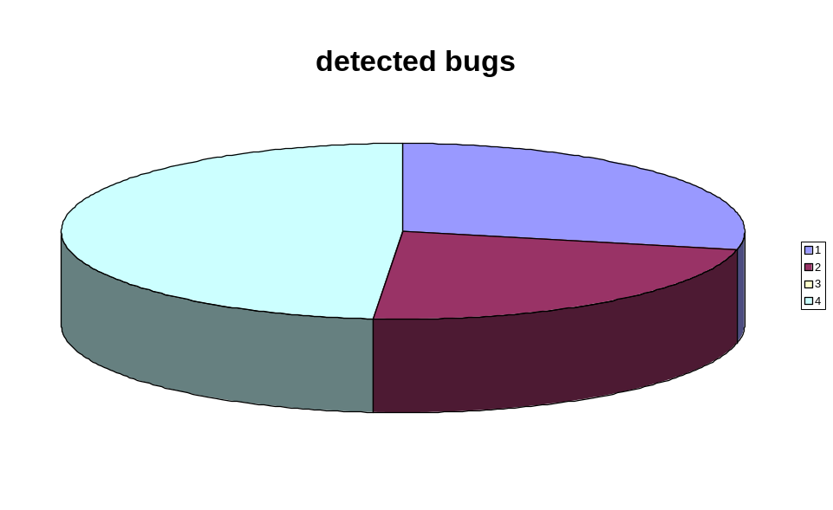

  - Bug distribution according to variables

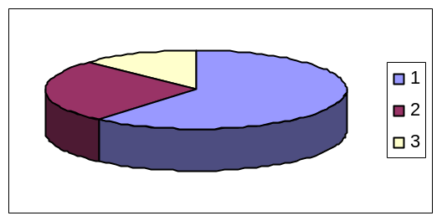
- supplier.supply_address
  - sleep 401
  - lock unlock : 192

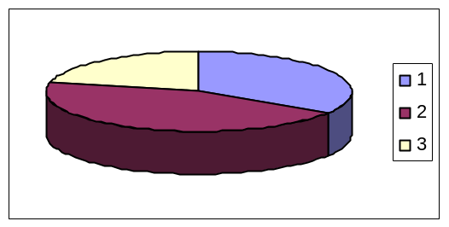
- costumer.my_shop
  - sleep : 682
  - lock unlock : 322

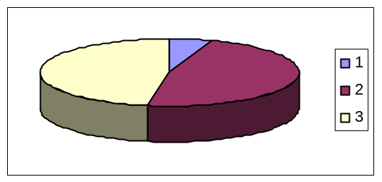

- shop.items
  - sleep : 720
  - lock unlock : 719

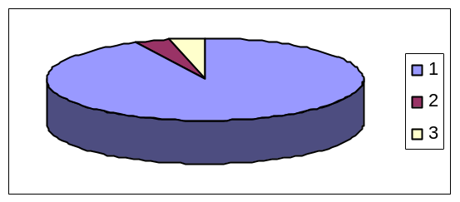
- Signal.i
  - sleep : 55
  - lock unlock : 55

- 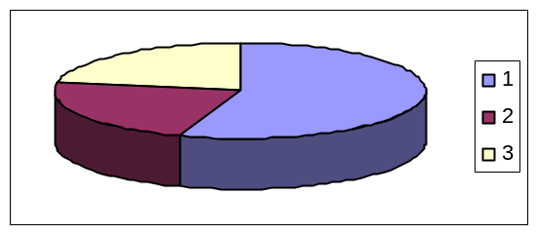shop.storage
  - sleep : 341
  - lock unlock : 340

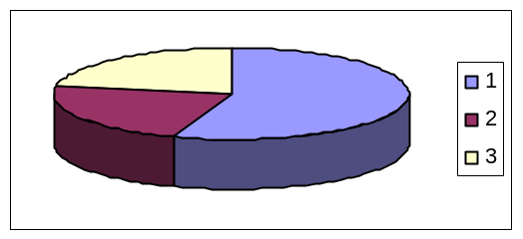
- Subsets of two variables
  - sleep : 134
  - lock unlock : 106

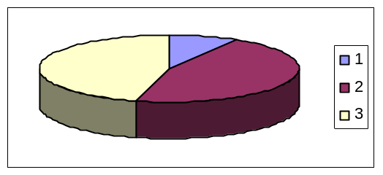
- White noise
  - sleep : 695
  - lock unlock : 695

  - distribution according to noise applied

- 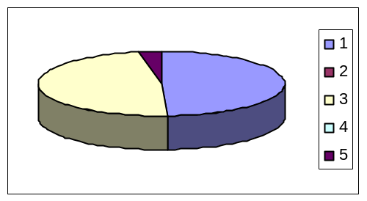Noise types

- yield : 2678
- barrier: 2615
- combination: 164

- 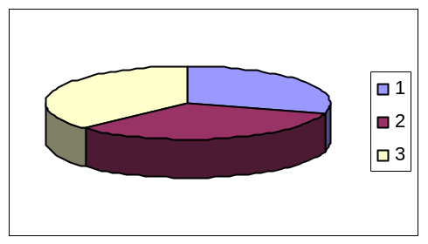yield noise levels

- low : 791
- average : 887
- high : 1000

- 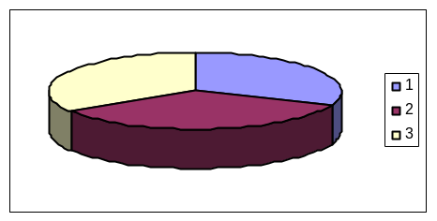barrier noise levels
  - low : 804
  - average : 917
  - high : 894

- Summary

51.28 percent of possible bugs were created by raceFinder, however taking a closer look at the tests tables improves the picture: only 23.6 percent of test groups resulted in no bugs at all as output, meaning that for a test group big enough the chances of finding a bug, if one does exist, increase dramatically. Out of these 23.6 percent of test sets in which no bugs were found, 63.49 percent of test sets were conducted on two specific variables.

The highest bug creating rates were caused by:
- applying noise to a sensitive shared variable :shop.items ( 94 percent of all possible bugs were created while testing this variable)
- by applying maximum noise to all variables (white noise) –this resulted in 91.4 percent of all possible bugs.

No clear distinction in favor of using any of noise levels was detected – differences between noise levels were few.
The same applies for yield versus barrier – no clear distinction as well.

